AI Assisted Research Evidence
B2B SaaS Market Intelligence
RESEARCH / 01

Dominant Players and Market Concentration in the B2B SaaS Industry
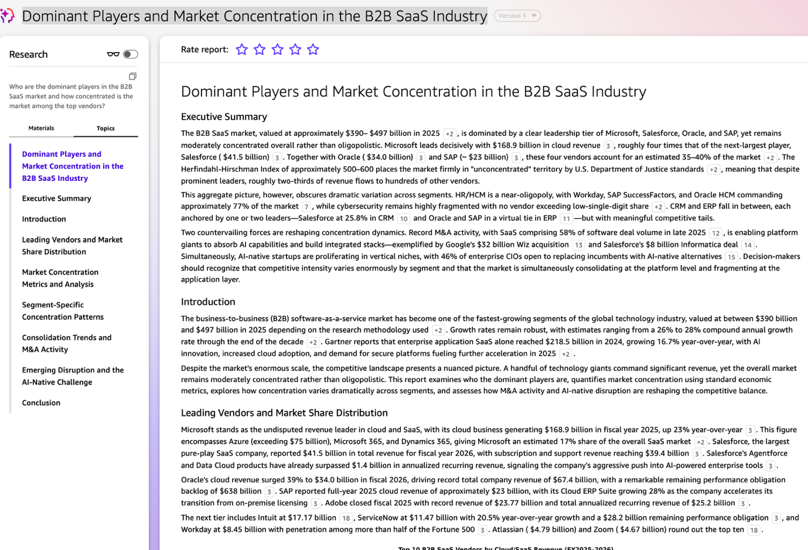
Figure 1. Research report screenshot.

RESEARCH / 02

Fastest-Growing SaaS Categories in 2024–2025: AI/ML, Cybersecurity, Collaboration, and Analytics
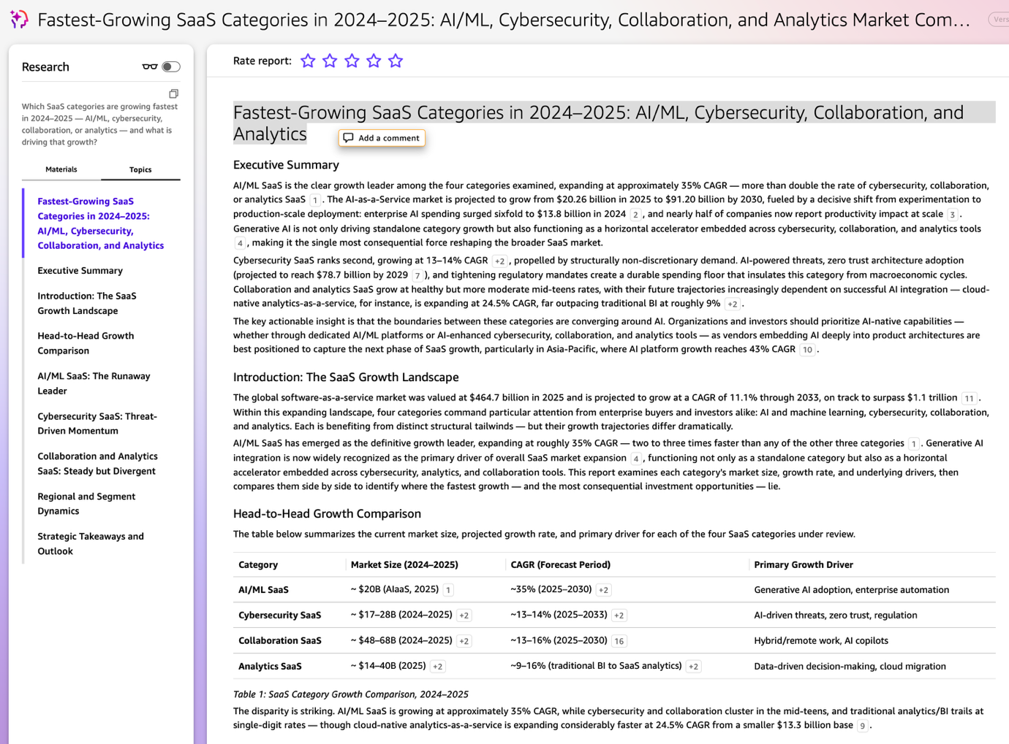
Figure 2. Research report screenshot.

RESEARCH / 03

Key Risks and Headwinds for New Entrants into the B2B SaaS Market in 2026
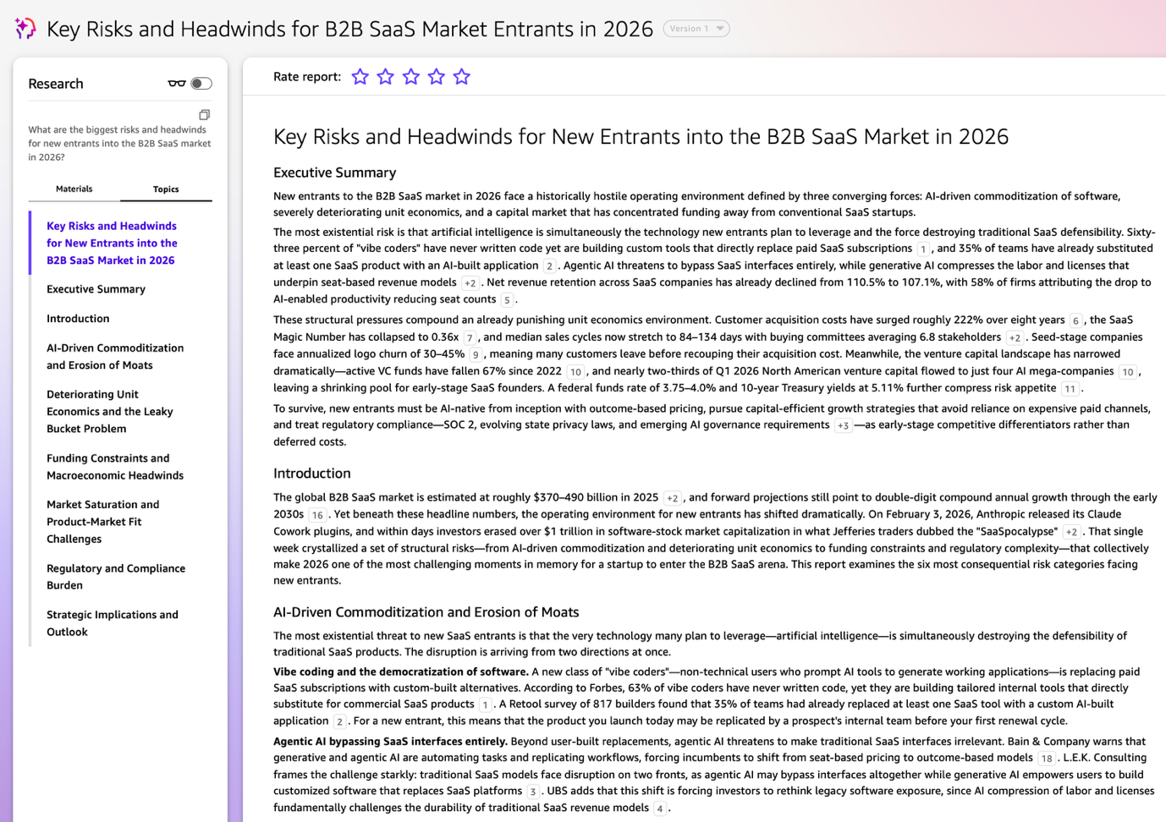
Figure 3. Research report screenshot.

RESEARCH / 04

SaaS Pricing Evolution 2024–2025: Adoption of Usage-Based and Hybrid Models
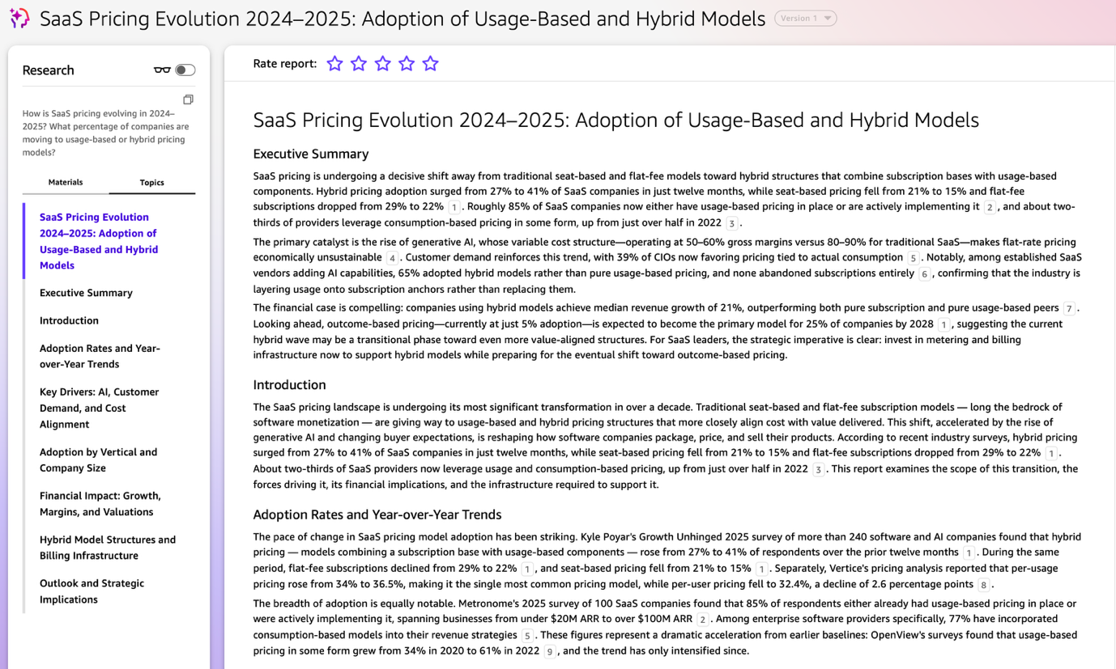
Figure 4. Research report screenshot.

CHAT AGENT / 05

Leadership Brief Generation
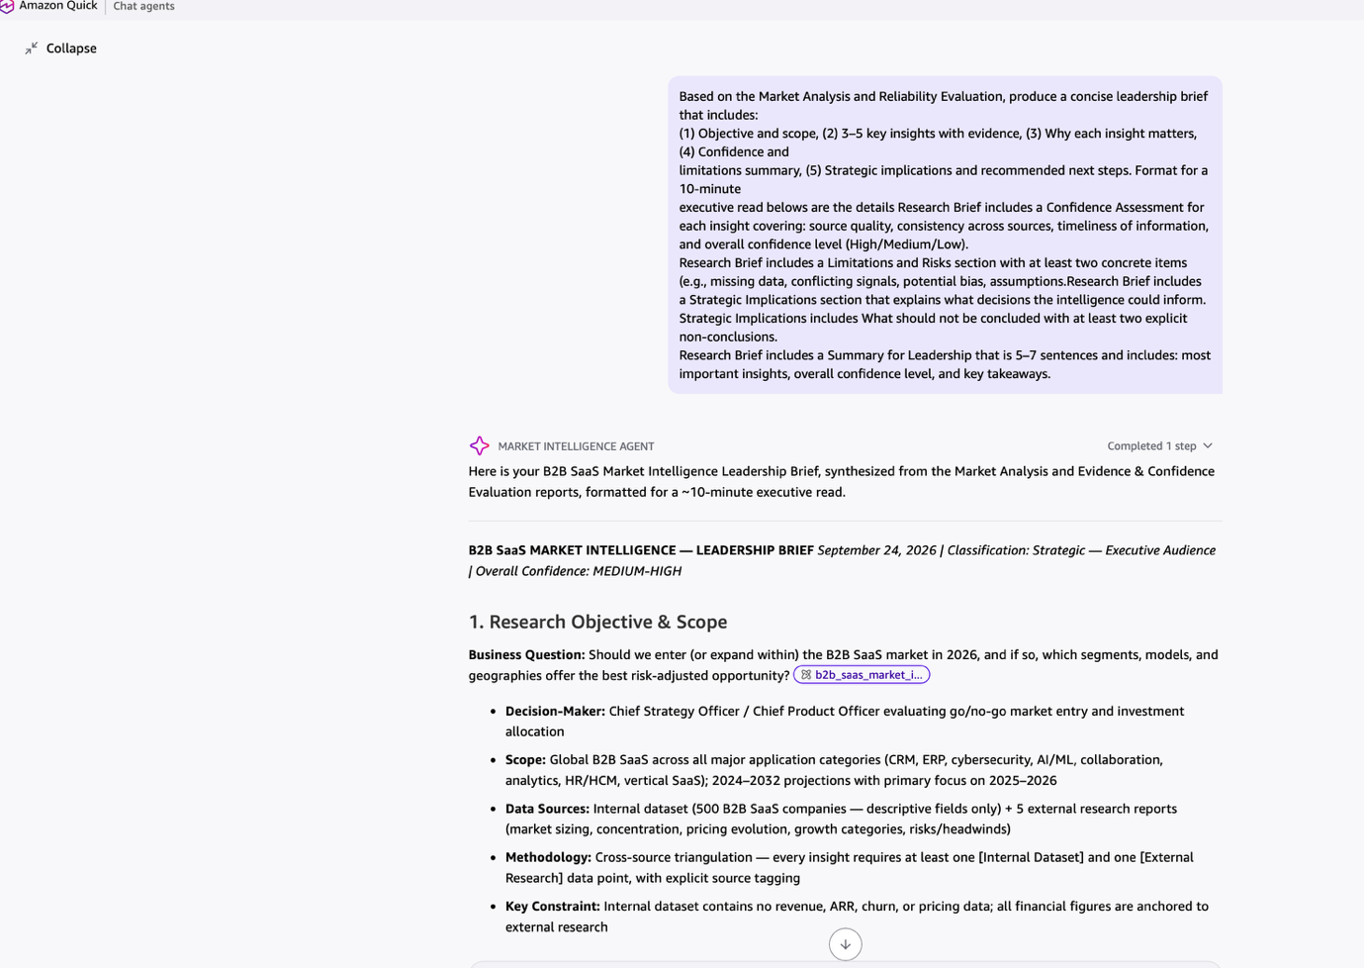
Figure 5. Chat agent screenshot.

CHAT AGENT / 06

Supporting Visualizations
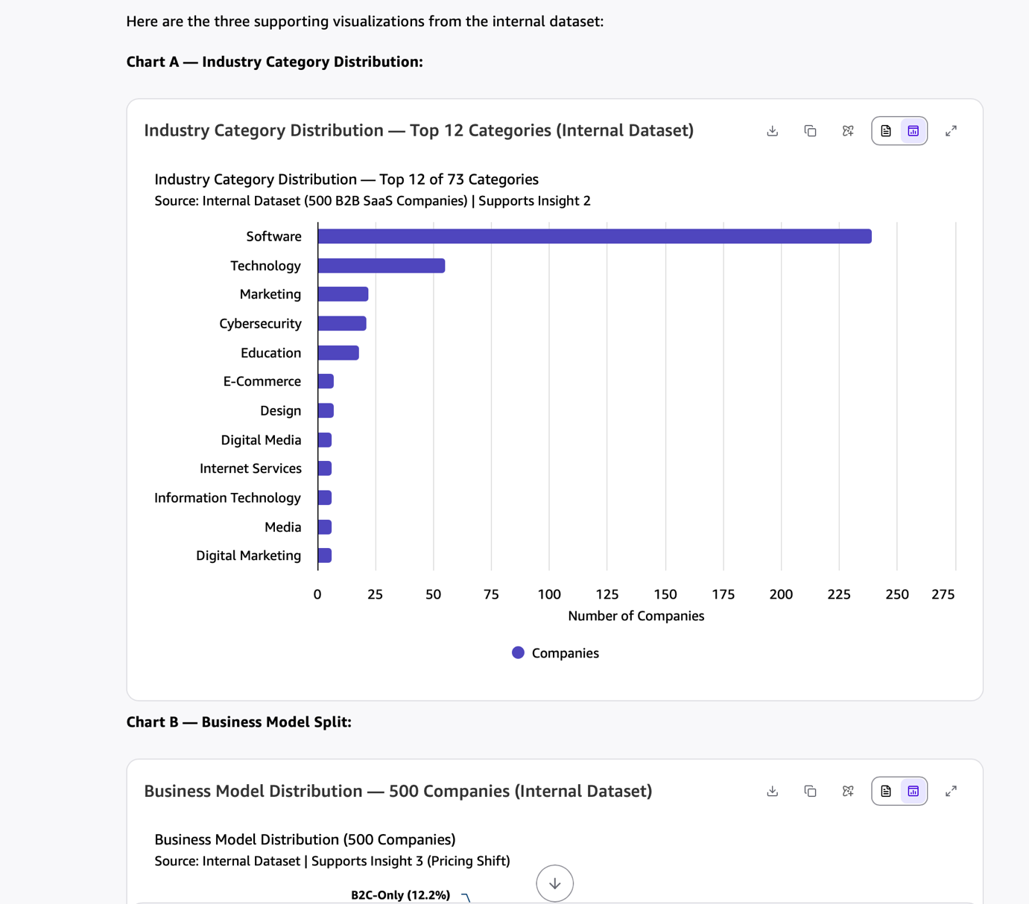
Figure 6. Chat agent screenshot.

